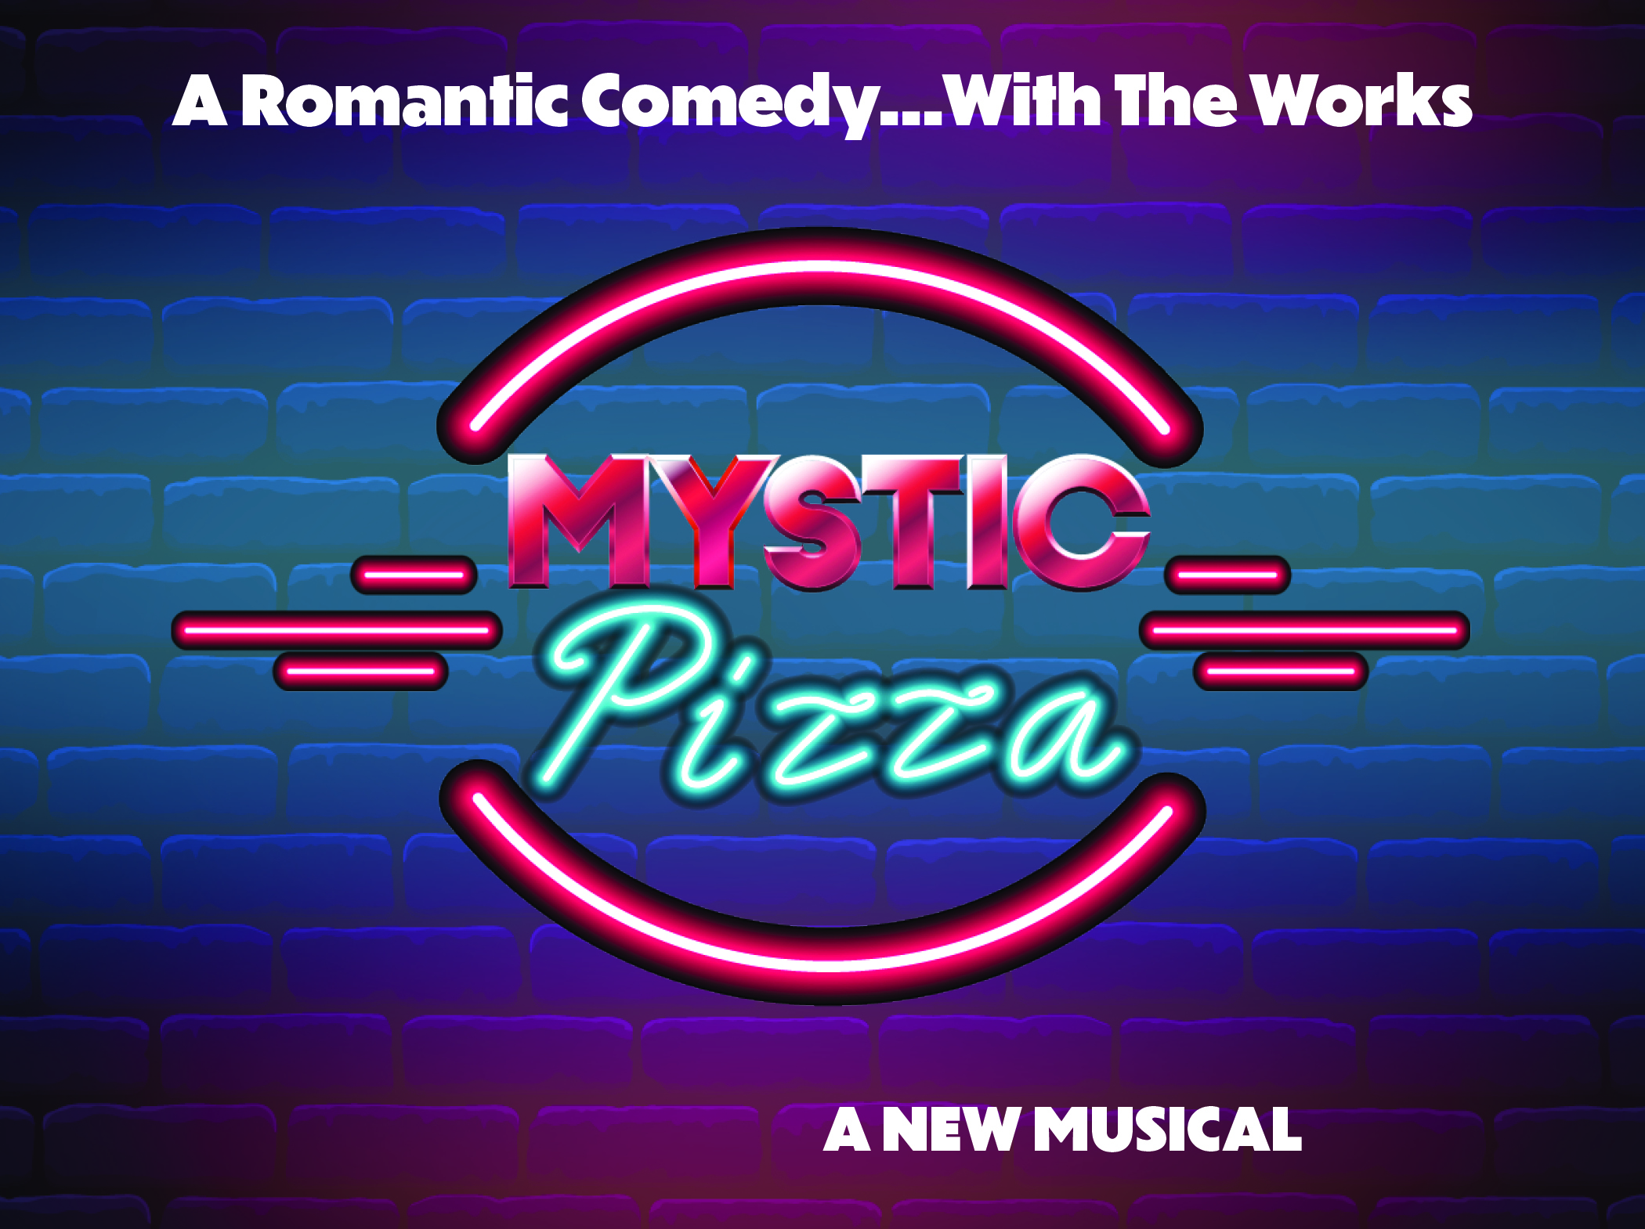
MYSTIC PIZZA
September 15 – October 30, 2022

FOR IMMEDIATE RELEASE:

(Northport, NY- September 2022) – The John W. Engeman Theater announces the cast and creative team of MYSTIC PIZZA - A New Musical. Performances begin on Thursday, September 15, 2022, and run through Sunday, October 30, 2022.

Based on the classic 1988 movie starring Julia Roberts, MYSTIC PIZZA charts the lives and loves of three unforgettable waitresses in the harbor town of Mystic, CT. Featuring some of the best pop songs of the ‘80s and ‘90s such as “Girls Just Wanna Have Fun,” “Addicted To Love,” “Small Town,” “Hold On,” and “Take My Breath Away,” MYSTIC PIZZA has all the ingredients for a romantic comedy–with the works!

MYSTIC PIZZA is directed by IGOR GOLDIN (Engeman Theater: Kinky Boots, Rock of Ages, Matilda, Newsies, Gypsy, Oklahoma, 1776; Off-Broadway: YANK!, With Glee, A Ritual of Faith; Regional: Seattle 5th Ave., Goodspeed Musicals, Cape Playhouse, Tuacahn Center for the Arts) and choreographed by ASHLEY MARINELLI (Engeman: West Side Story; Off-Broadway: Stranger Sings!: The Parody Musical, Dorothy Parker: The Musical; Regional: Miller Theater, The Players Club, Ogunquit Playhouse, Tuacahn Center for the Arts).

The Creative Team includes SARAH WUSSOW (Musical Director), KYLE DIXON (Scenic Design), DUSTIN CROSS (Costume Design), JOSE SANTIAGO (Lighting Design), LAURA SHUBERT (Sound Design), KRISTIE MOSCHETTA (Props Design), WOJCIK CASTING TEAM (Casting Directors), AARON A. WATSON (Production Stage Manager), KAYLA GOLDSBOROUGH (Assistant Stage Manager), TIGER BROWN (Associate Choreographer), JENNIFER COLLESTER (Director of Production) and RICHARD DOLCE (Producing Artistic Director).

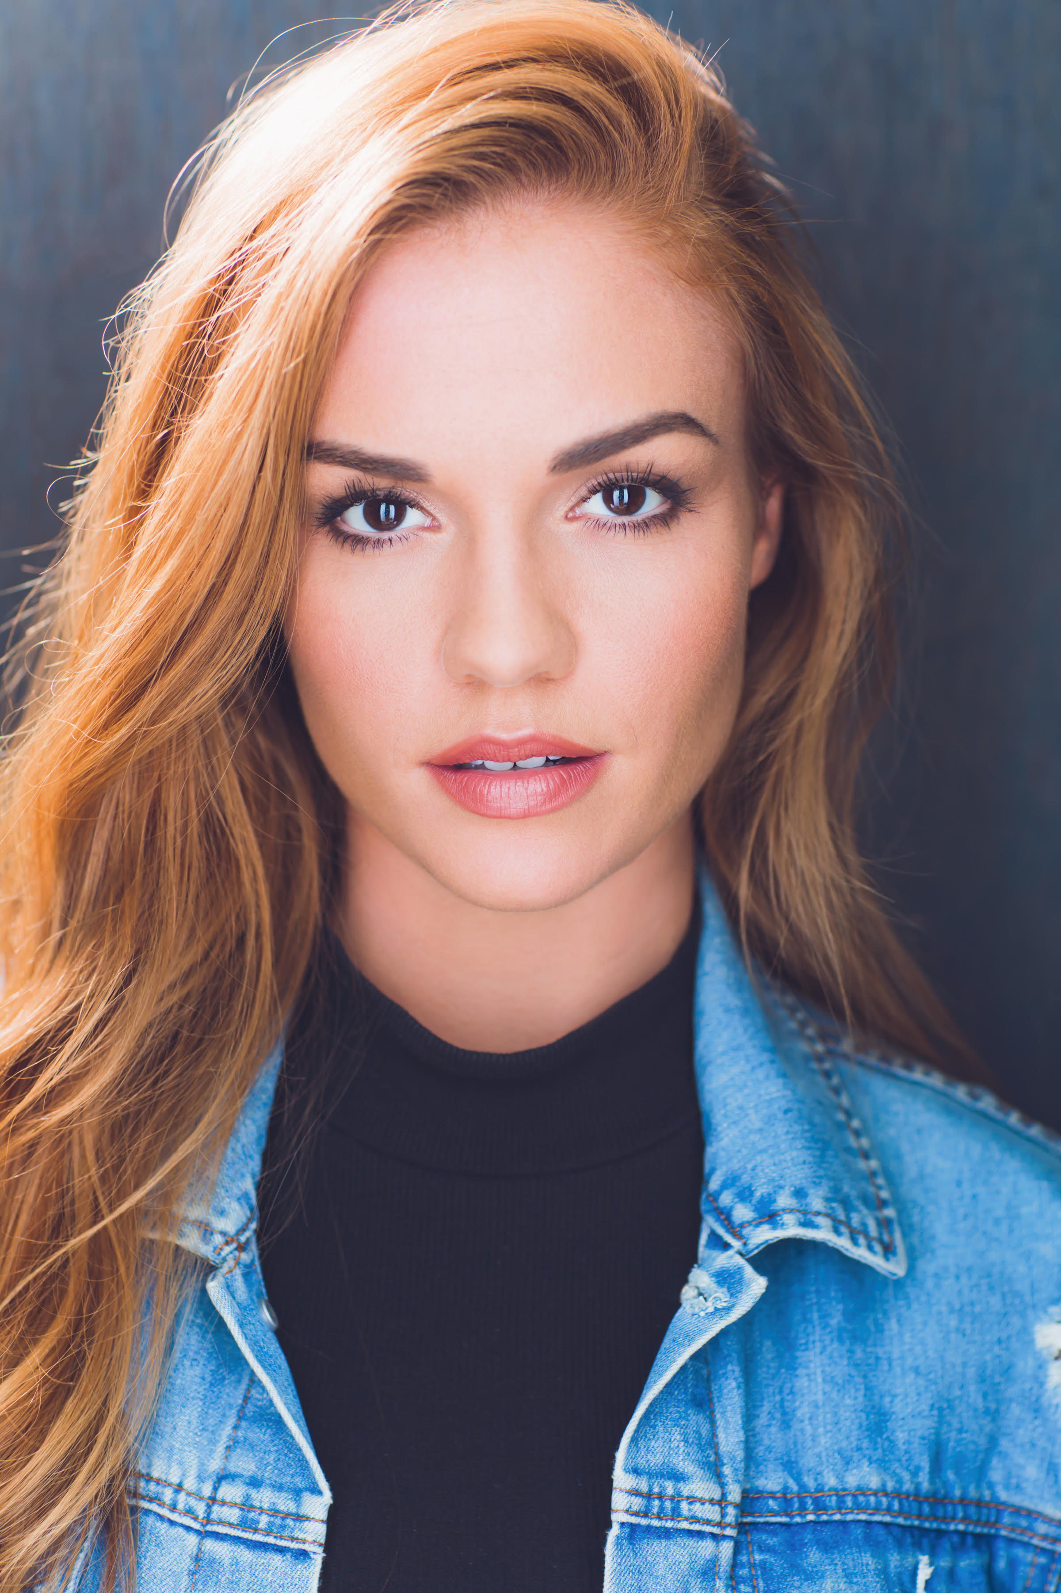 |  |  | 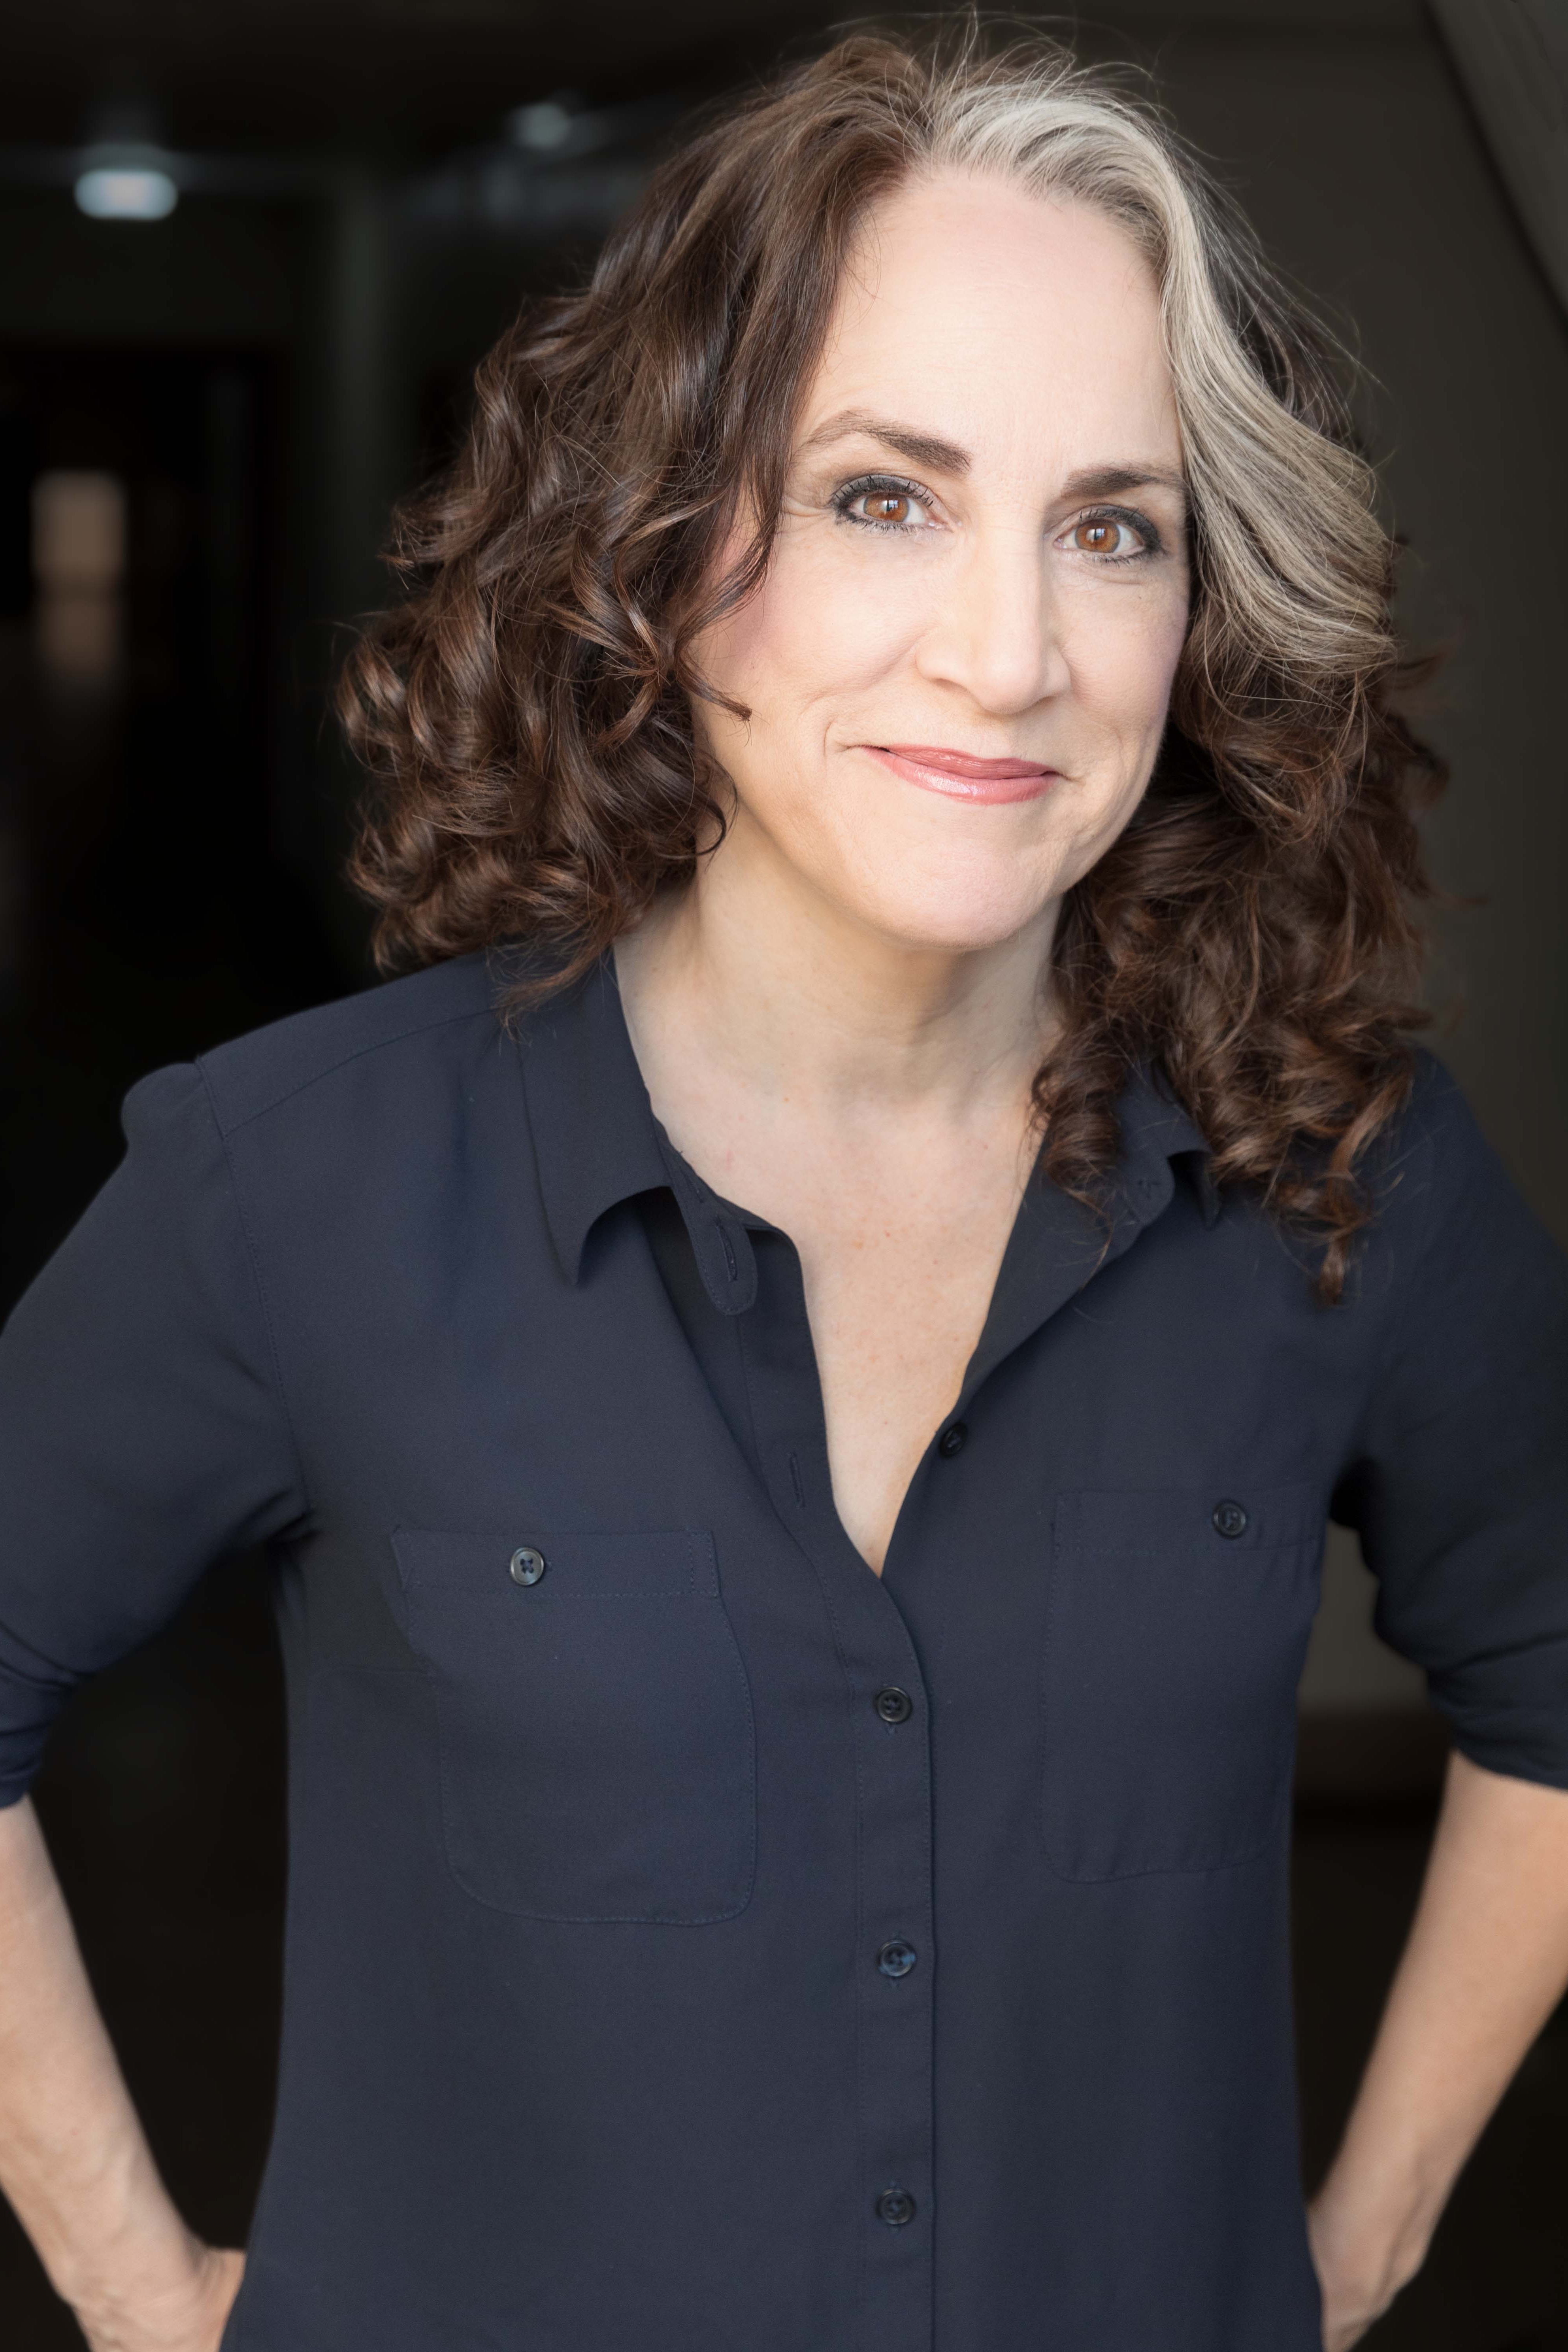
Emily Rose Lyons  as Daisy | Brooke Sterling  as Kat | Michelle Beth Herman as Jojo | Kathryn Markey  as Leona

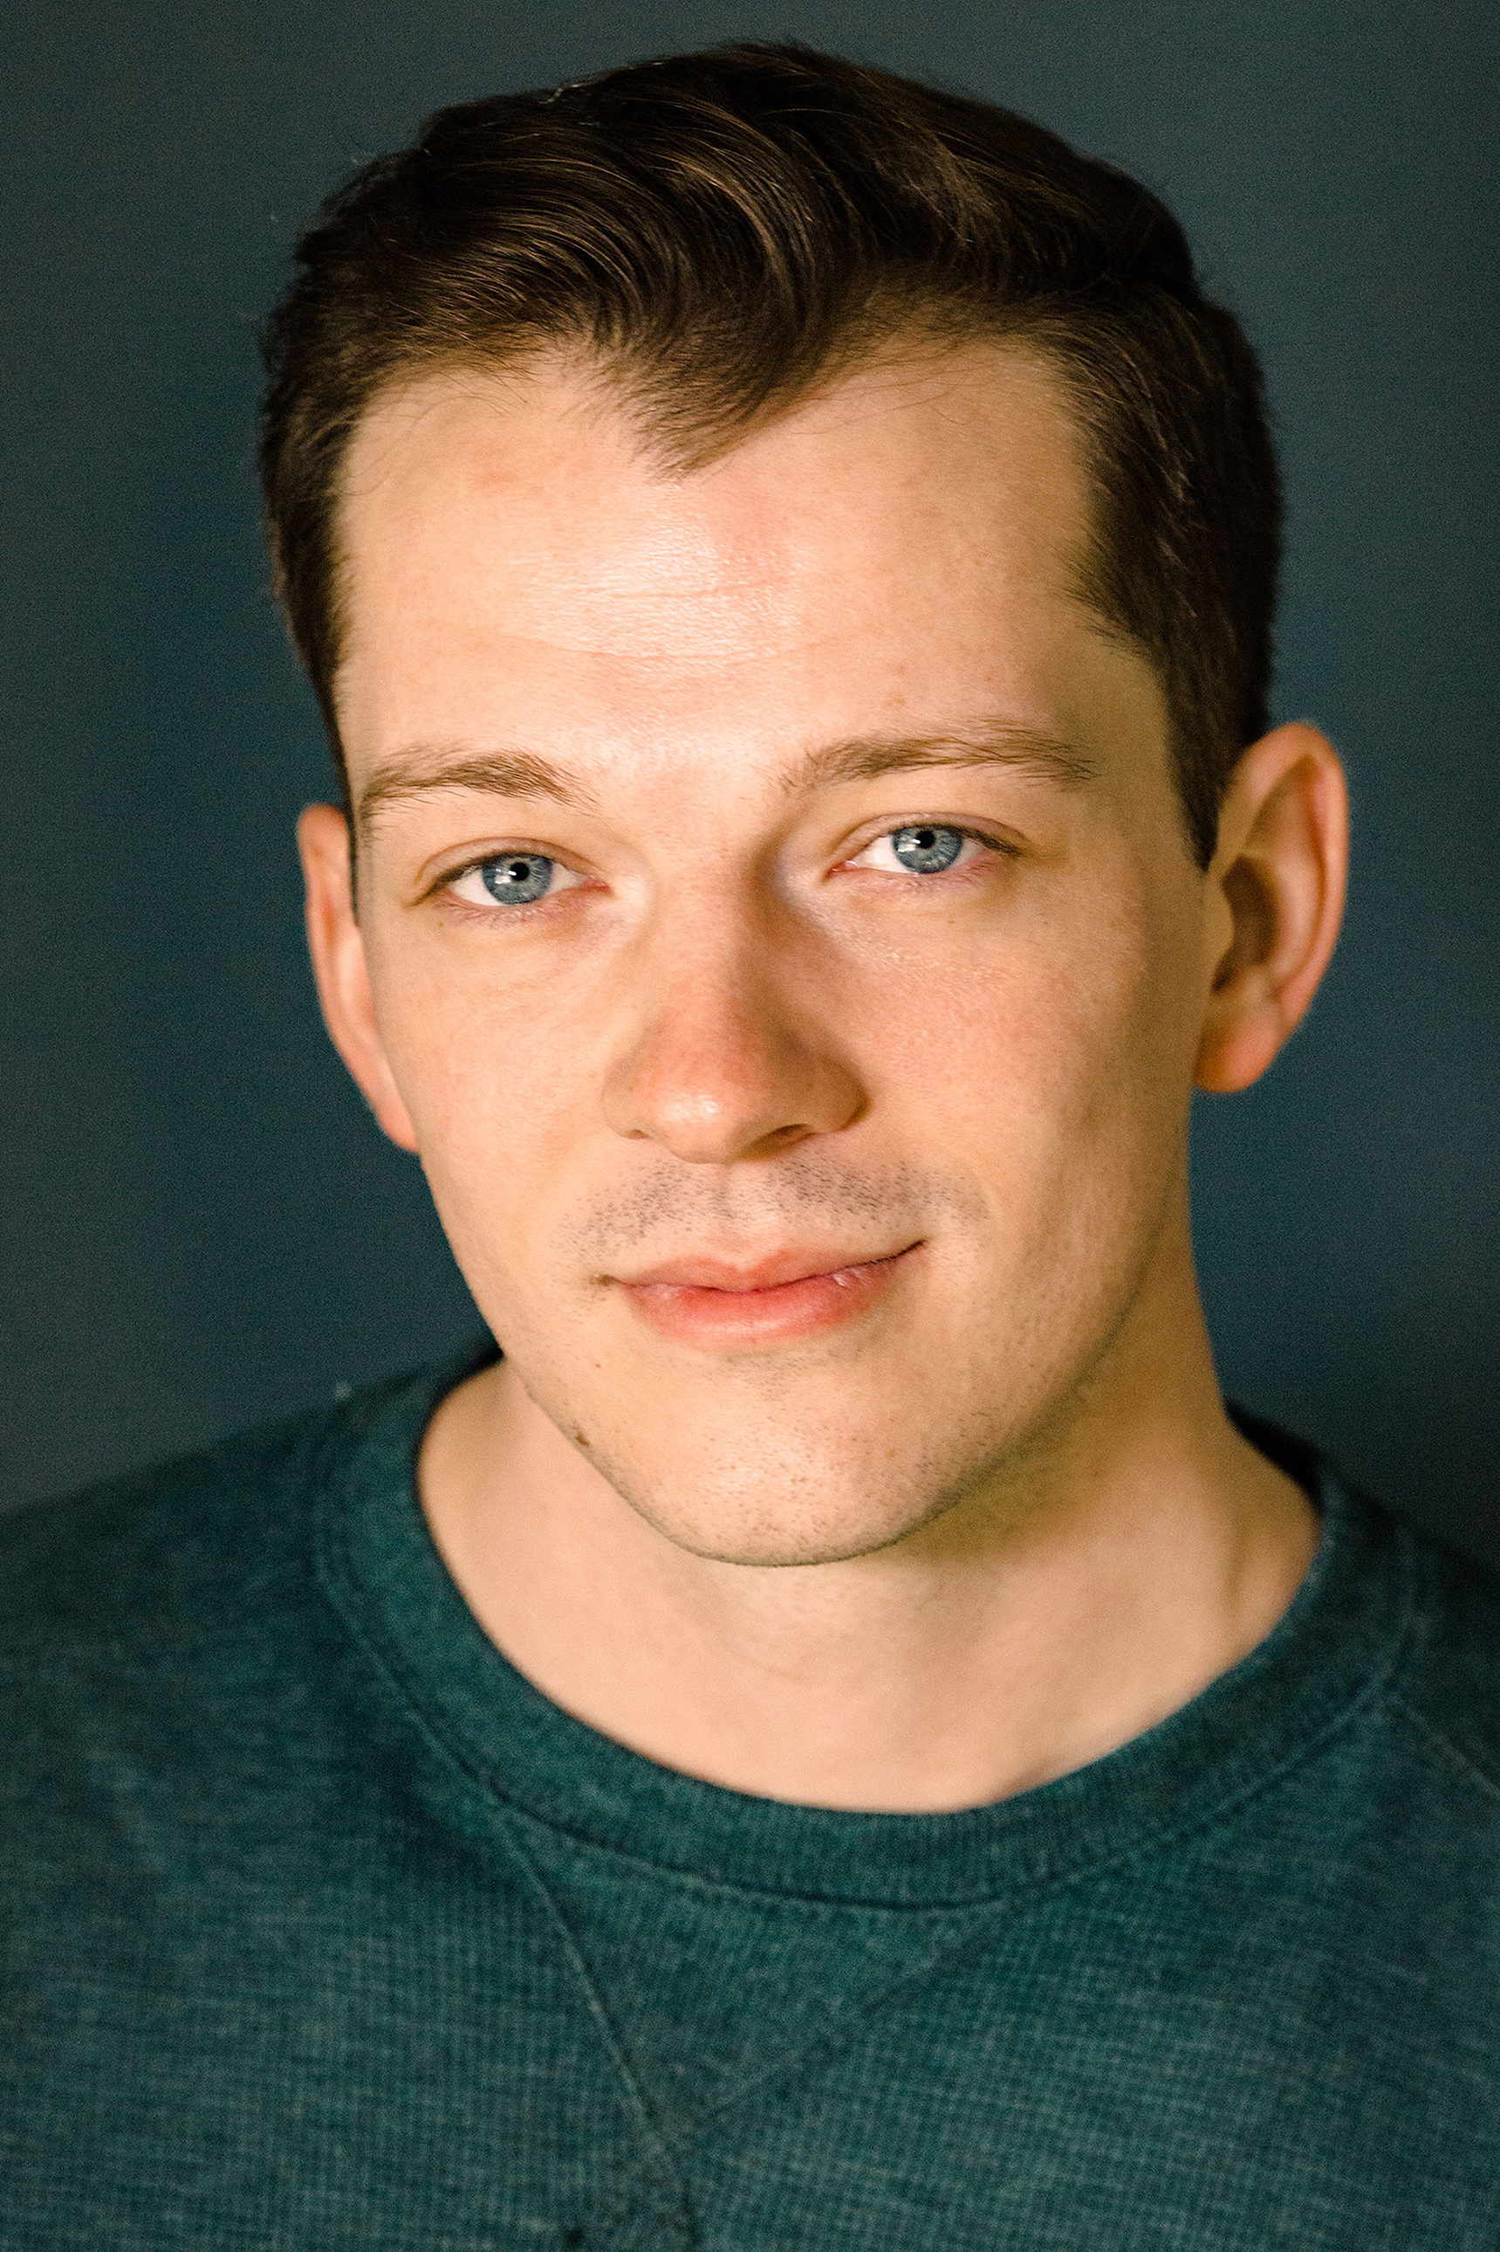 | 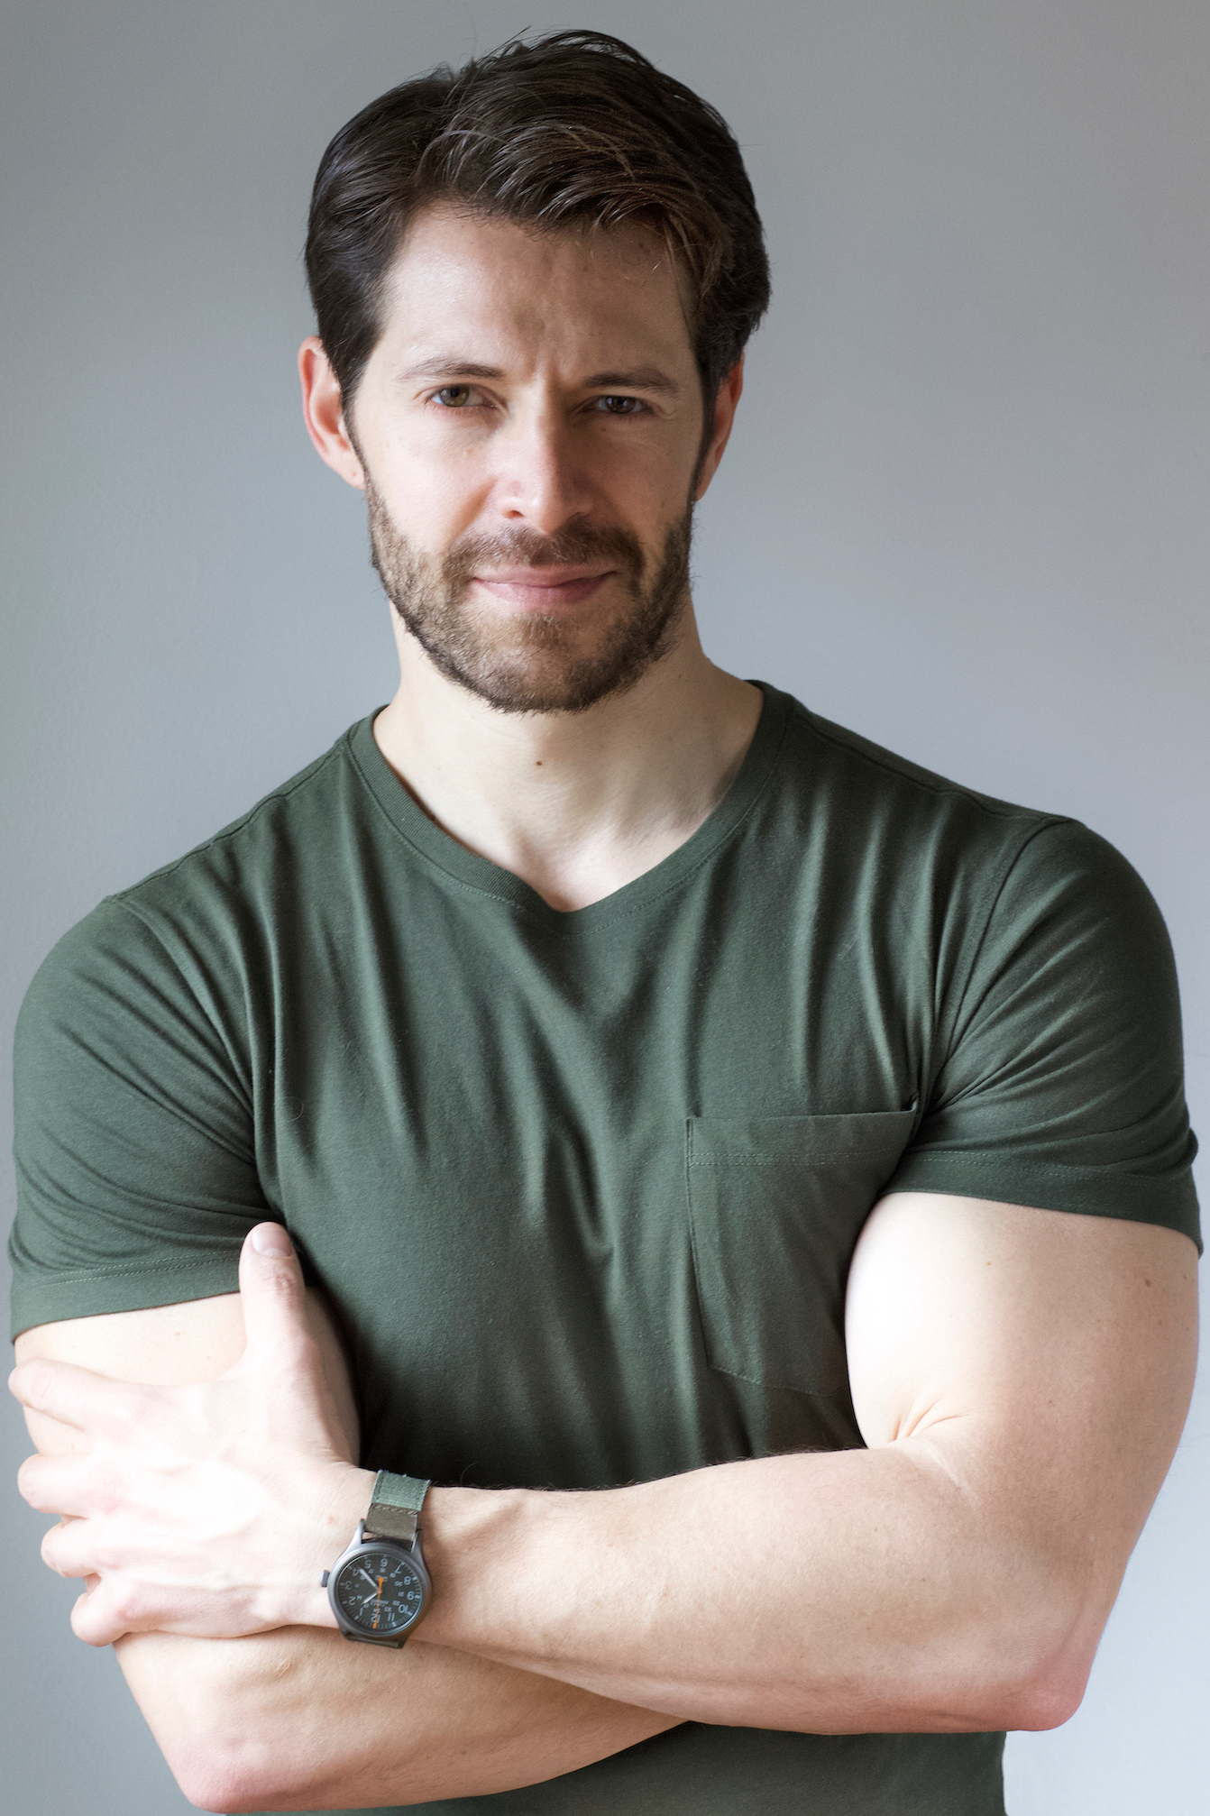
Corbin Payne  as Tim | Stephen Cerf  as Bill | Jake Bentley Young  as Charlie

The cast of MYSTIC PIZZA features EMILY ROSE LYONS as DAISY (National Tour: Legally Blonde; Regional: Norwegian Cruise Lines, Sierra Repertory Theatre, Royal Caribbean Cruises, Sundance Theatre, Hale Center Theatre), BROOKE STERLING as KAT (Regional: Richard Rodgers Amphitheater, Woodstock Playhouse, The Muny, Manhattan Theatre), MICHELLE BETH HERMAN as JOJO (National Tour: Les Miserables; Regional: Peterborough Players, MUNY, Northern Stage, TUTS, Mason Street Warehouse), KATHRYN MARKEY as LEONA (Engeman: Memphis, A Christmas Story; Broadway: 3 From Brooklyn; Regional: InProximity Theatre, Depot Theatre, St. Michael’s Playhouse, Alliance Theatre, Bay Street Theatre; TV/Film” “Law and Order,” “All My Children”), CORBIN PAYNE as TIM (Off-Broadway: Cleopatra; Regional: Short North Stage, The Denver Center, The Arvada Center, Ignite! Theatre), STEPHEN CERF as BILL (Engeman: Fiddler on the Roof; Broadway: Jersey Boys; National Tour: Motown The Musical, Spamalot, Rock Of Ages, Nevermore, That Bachelorette Show; Regional: Papermill Playhouse, Ogunquit Playhouse), and JAKE BENTLEY YOUNG as CHARLIE (Regional: Stages St. Louis, Wagon Wheel Center of the Arts, Lyric Theatre of Oklahoma).
The ensemble includes CAREY BLACKBURN, COLEMAN CUMMINGS, BRANDON KALLEN, KENT M. LEWIS, PARIS MARTINO, MICHAEL MORLEY, ANDRYI NAHIRNIAK, BRANDT NORRIS, HANNAH RECORD, MOLLY SAMSON, and ELISE SHANGOLD.
Press Opening is Saturday, September 17 at 8:00 pm.

MYSTIC PIZZA will play the following performance schedule: Thursdays at 8:00pm, Fridays at 8:00pm, Saturdays at 3:00pm and 8:00pm, and Sundays at 2:00pm. Some Wednesday and Sunday evenings are available. Tickets are $85 for Saturday evenings and $80 for all other performances. They may be purchased by calling 631-261-2900, going online at www.engemantheater.com, or by visiting the Engeman Theater Box Office at 250 Main Street, Northport.

The John W. Engeman Theater at Northport is Long Island's only year-round professional theater company, casting actors from the Broadway talent pool. From curb to curtain, we have made it our business to provide affordable, quality theater in an elegant one-of-a-kind location with outstanding facilities and extraordinary service. The renovated theater offers stadium-style seating, state-of-the-art lighting and sound, a full orchestra pit, and a classic wood-paneled piano lounge with full bar.

For a complete show schedule and more information contact the theater directly at 631-261-2900, visit the box office at 250 Main Street, Northport or visit www.engemantheater.com.

###

